Ideation Phase
Empathize & Discover

Date | 31 January 2026
Team ID | LTVIP2026TMIDS25024
Project Name | Visualizing Housing Market Trends: An Analysis of Sale Prices and Features using Tableau
Maximum Marks | 4 Marks

Empathy Map Canvas:
Understand the needs, challenges, and expectations of users such as data analysts, students, and stakeholders who want to analyse and interpret housing market data effectively. The goal is to identify how users interact with housing datasets, what difficulties they face in understanding raw data, and how interactive Tableau dashboards and visualizations can help them explore housing price trends, renovation impact, and structural characteristics in a clear, meaningful, and user-friendly manner.
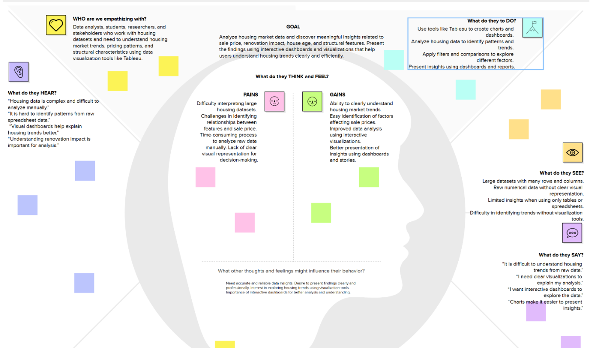
Link: https://app.mural.co/t/visualizinghousemarkettrends6575/m/visualizinghousemarkettrends6575/1771327369589/6ba9e4076cfc993ebd2fa6c129eae734a21c5e94?sender=u47c9bca3661e3dc3996a2844
Reference: https://www.mural.co/templates/empathy-map-canvas

